Populating Default Value using Triggers in Oracle
Let us understand How to populate a Default Value into a table using Triggers with Examples. We will be creating a table called customers. So, let’s go ahead and create a table named customers with the columns as cust_id where the datatype is number, the name with datatype as varchar2(100), and the status with datatype as char(1) as follows.
Create table customers
(
cust_id number,
Name varchar2(100),
Status char(1)
);
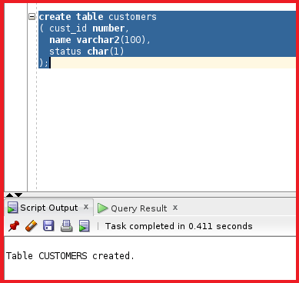
So, the customers table is created. From the customers table, we can see a column called status. We are going to use that column in triggers and whenever a “BEFORE UPDATE” event occurs, then the trigger will populate a default value to the status column. For example, if a student scores above 35 then a trigger will populate the status column with value A in the table. So, let us go ahead and create the trigger by executing the following statement.
Create or replace trigger customer_default_status
Before insert
On customers
For each row
Begin
:new.status=’A’;
End;
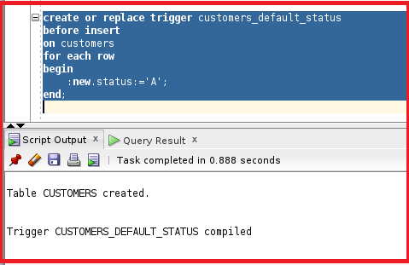
So, the trigger is created and compiled. From the trigger create a statement, and you can see any value inserted to the table customers, the new value will be updated to the column status. Let us go ahead and test the trigger by inserting a record into the table customers table by executing the below INSERT SQL Statement.
Insert into customers (cust_id, name) values (1,’abc’);
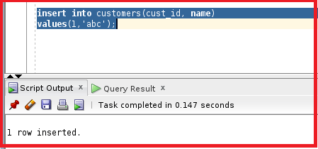
So, the row is inserted into the customers table. Let us check the status column and see if the trigger is executed or not by executing the following SELECT Statement
select * from customers;
